Donate an Auction Item and Join the BolderLife Efforts!

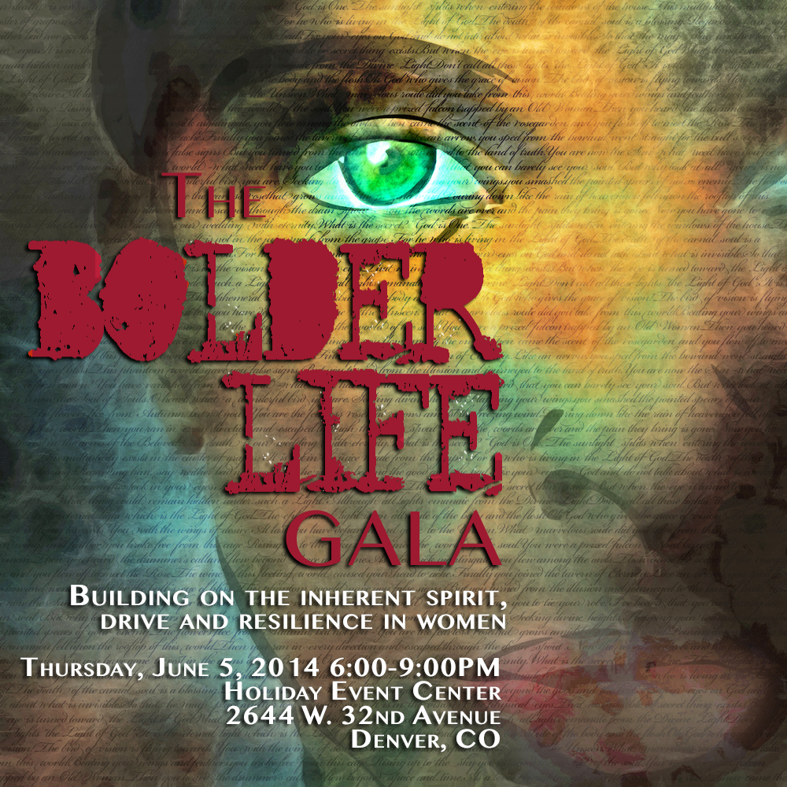
The 2014 BolderLife Gala is set for Thursday, June 5th from 6:00-9:00PM at the Holiday Event Center. The Gala: Building on the Inherent Spirit, Drive and Resilience in Women will feature cocktails, live and silent auctions, epicurean delights and entertainment – in support of the BolderLife Women’s Leadership Programming that will be delivered at our 2014 Festival in October. Also, we are proud to announce that 50% of the proceeds from the Gala will benefit SafeHouse Denver, a non-profit organization which serves victims of domestic violence through both an Emergency Shelter and non-residential Counseling and Advocacy Center.
Through our Women’s Leadership Programming, our goal is to empower women by igniting personal and group transformation. The outcome we seek is to equip women with skills for action in the real world, whether at a personal level, within their career or in and around their community. Your support as an auction donor will help us provide exceptional Women’s Programming including Keynote Speakers, Educational Workshops and Panel Discussions paired with the artistic platforms, such as film and theatre, we use to stimulate learning openly and as a community. In addition, you will be helping SafeHouse Denver provide critical services to survivors of domestic violence, raise awareness and create a community that will not tolerate abuse.

Your tax-deductible donation to our auction will help us reach our 2014 funding goal while demonstrating your commitment to the community. Auction donors will be highlighted in a looping PowerPoint presentation set to run the night of the event, reaching approximately 150 guests.
The BolderLife Festival is a 501(c)3 non-profit organization that supports emotional education and growth with programming aimed at high-school students and the wider community. We introduce difficult and taboo topics through film, theatre, and dance, and then deepen the conversation with professional speakers and workshops that help audiences explore discomfort, cultivate mindfulness and live in courage. Our event brings community together to learn and grow both locally at our yearly event and internationally through our live-stream. For filmmakers, artists, educators and those fueled by inspiration; the adventurers and the passionately curious, the BolderLife Festival provides a common platform for these extraordinary people to share their life stories, purpose and innovation.
For more information about donating to the BolderLife Gala Auction, please contact Diane Feliciano at 847.977.3982 or by email at diane.m.feliciano@gmail.com. Alternatively, you may also contact the BolderLife committee member who contacted you.

